محمد کاظم رجبی 96222039

Our data set contains a set of images of different houses and a csv file contain various information about each house and with this data set i should predict the price of house:

Main idea :implementing a mlp and cnn according to this approch and combine them :

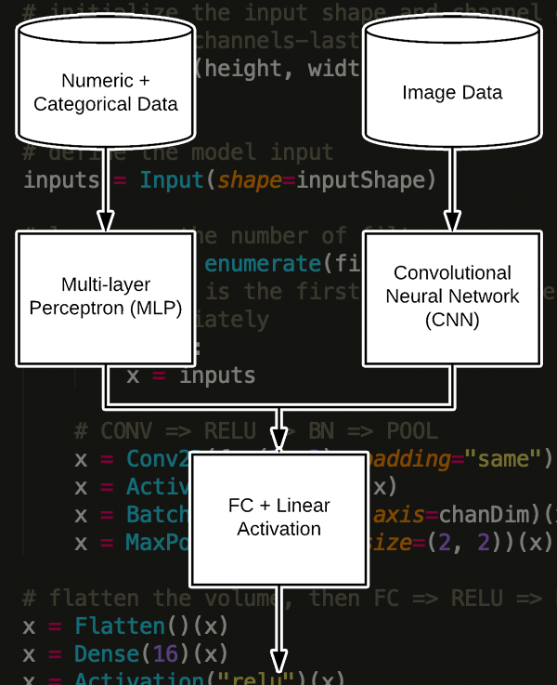

Firs normalize the data-set:

house_feature['n_city']=house_feature['n_city']/max(house_feature['n_city'])

house_feature['bed']=house_feature['bed']/max(house_feature['bed'])

house_feature['sqft']=house_feature['sqft']/house_feature['sqft']

house_feature['bath']=house_feature['bath']/max(house_feature['bath'])

house_feature['price']=house_feature['price']/max(house_feature['price'])

one sample of data:

(311, 415, 3)

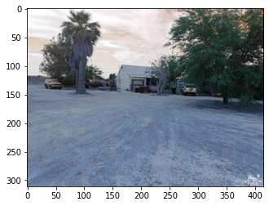

Resize pictures:

import os

import cv2

counter=0

images=np.zeros((15474,128,128,3),dtype='uint32')

for i in range(15474):

    sample=cv2.imread('pics/pics'+'/'+str(i)+'.jpg')

    imgs=cv2.resize(sample,(128,128))

    images[counter]=imgs

    counter+=1

The first data-set contains a some images with the image_id name that exist in the secent data-set with same number .I ignore the first three column because they are not important and divide data set to train and test data-set:

from sklearn.model_selection import train_test_split

split = train_test_split(house_feature, images, test_size=0.2, random_state=42)

(X_train,X_test,Ximage_train,Ximage_test) = split

y_train , y_test = X_train['price'].values , X_test['price'].values

X1_train=X_train[['n_city','bed','bath','sqft']].values

X2_train=Ximage_train

X1_test=X_test[['n_city','bed','bath','sqft']].values

X2_test=Ximage_test

Firs model:

   model1 = Sequential()

    model1.add(Dense(8, input_dim=X1_train.shape[1], activation="relu"))

    model1.add(Dense(4, activation="relu"))

I put 4 nodes in last layer becues this should compatible with image arrays .

Cnn model:

 inputShape = (128,128,3)

    inputs = Input(shape=inputShape)

    x = Conv2D(32, (3, 3), padding="same")(inputs)

    x = Activation("relu")(x)

    x = BatchNormalization(axis=-1)(x)

    x = MaxPooling2D(pool_size=(2, 2))(x)

    x = Conv2D(32, (3, 3), padding="same")(x)

    x = Activation("relu")(x)

    x = BatchNormalization(axis=-1)(x)

    x = MaxPooling2D(pool_size=(2, 2))(x)

    x = Conv2D(32, (3, 3), padding="same")(x)

    x = Activation("relu")(x)

    x = BatchNormalization(axis=-1)(x)

    x = MaxPooling2D(pool_size=(2, 2))(x)

    x = Flatten()(x)

    x = Dense(4)(x)

    x = Activation("relu")(x)

    model2 = Model(inputs, x)

The most important part is combination of these :

combinedInput = concatenate([model1.output, model2.output])

x = Dense(4, activation="relu")(combinedInput)

x = Dense(1, activation="linear")(x)

after this I test the same data-set with just mlp model (without cnn model)and the result are the same ,therefore these images cannot help our neural network .

Model: "functional_3"

__________________________________________________________________________________________________

Layer (type) Output Shape Param # Connected to

==================================================================================================

input_1 (InputLayer) [(None, 128, 128, 3) 0

__________________________________________________________________________________________________

conv2d (Conv2D) (None, 128, 128, 32) 896 input_1[0][0]

__________________________________________________________________________________________________

activation (Activation) (None, 128, 128, 32) 0 conv2d[0][0]

__________________________________________________________________________________________________

batch_normalization (BatchNorma (None, 128, 128, 32) 128 activation[0][0]

__________________________________________________________________________________________________

max_pooling2d (MaxPooling2D) (None, 64, 64, 32) 0 batch_normalization[0][0]

__________________________________________________________________________________________________

conv2d_1 (Conv2D) (None, 64, 64, 32) 9248 max_pooling2d[0][0]

__________________________________________________________________________________________________

activation_1 (Activation) (None, 64, 64, 32) 0 conv2d_1[0][0]

__________________________________________________________________________________________________

batch_normalization_1 (BatchNor (None, 64, 64, 32) 128 activation_1[0][0]

__________________________________________________________________________________________________

max_pooling2d_1 (MaxPooling2D) (None, 32, 32, 32) 0 batch_normalization_1[0][0]

__________________________________________________________________________________________________

conv2d_2 (Conv2D) (None, 32, 32, 32) 9248 max_pooling2d_1[0][0]

__________________________________________________________________________________________________

activation_2 (Activation) (None, 32, 32, 32) 0 conv2d_2[0][0]

__________________________________________________________________________________________________

batch_normalization_2 (BatchNor (None, 32, 32, 32) 128 activation_2[0][0]

__________________________________________________________________________________________________

max_pooling2d_2 (MaxPooling2D) (None, 16, 16, 32) 0 batch_normalization_2[0][0]

__________________________________________________________________________________________________

dense_input (InputLayer) [(None, 4)] 0

__________________________________________________________________________________________________

flatten (Flatten) (None, 8192) 0 max_pooling2d_2[0][0]

__________________________________________________________________________________________________

dense (Dense) (None, 8) 40 dense_input[0][0]

__________________________________________________________________________________________________

dense_2 (Dense) (None, 4) 32772 flatten[0][0]

__________________________________________________________________________________________________

dense_1 (Dense) (None, 4) 36 dense[0][0]

__________________________________________________________________________________________________

activation_3 (Activation) (None, 4) 0 dense_2[0][0]

__________________________________________________________________________________________________

concatenate (Concatenate) (None, 8) 0 dense_1[0][0]

activation_3[0][0]

__________________________________________________________________________________________________

dense_3 (Dense) (None, 4) 36 concatenate[0][0]

__________________________________________________________________________________________________

dense_4 (Dense) (None, 1) 5 dense_3[0][0]

==================================================================================================

Total params: 52,665